Sharif Ayesh

March 15, 2025

2-3 Assignment

**2-3 Milestone One: Project Proposal**

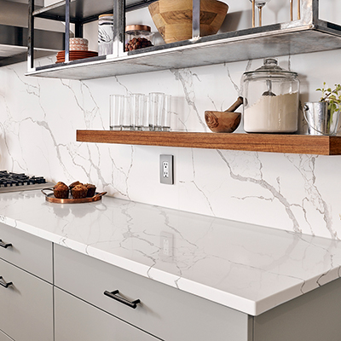

For my 3D scene project proposal, I chose a clean and modern kitchen countertop setup. The image shows a marble counter with a few everyday items arranged neatly, like a glass jar, a wooden bowl with a spoon, some muffins on a plate, and a few glasses on a floating wooden shelf. I picked this scene because it’s simple, realistic, and easy to break down into basic 3D shapes, making it a perfect fit for this project. It also allows me to work with different materials like glass, wood, and stone textures, all within a small and manageable space.

To start, I’ll use a large box and a plane to build the main counter surface. The muffins can be modeled using cylinders for the bases and spheres for the rounded tops. For the glasses on the shelf, I’ll stick with tall cylinders that are easy to replicate and let me experiment with transparency and lighting later. The large glass jar will also be a cylinder, with a simple cone or flat sphere for the lid.

The wooden bowl is another good example of a basic shape; it can be made using a tapered cylinder or a partially hollowed sphere. I’ll also model the spoon inside using a skinny cylinder for the handle and a shallow scoop made from a cone or small sphere segment. If time allows, I might include the small plant in the corner using a cylinder for the pot and some cones or spheres for the greenery.

This scene checks all the boxes for the assignment. It includes a variety of basic shapes, at least one compound object, and a grounded layout with a plane as the base. It’s not overly complex, but it still allows me to practice lighting, shadows, and applying different textures. It also feels like something you'd see in everyday life, which I think adds to its realism and relatability.

Overall, I think this kitchen countertop scene is a great fit for my 3D modeling project. It’s practical, clean, and gives me a solid mix of objects to work with, while still being doable within the project scope. I look forward to building it in OpenGL and bringing it to life with lighting and materials.

References:

Lowe’s. *Modern kitchen countertop with marble and wooden accessories*. Lowe’s. <https://www.lowes.com>